Ben Sottile

Discovery Exercises

6.Create a variable called iam and assign the results of the whoami command to it. Dis-play the contents of the variable to verify your results.

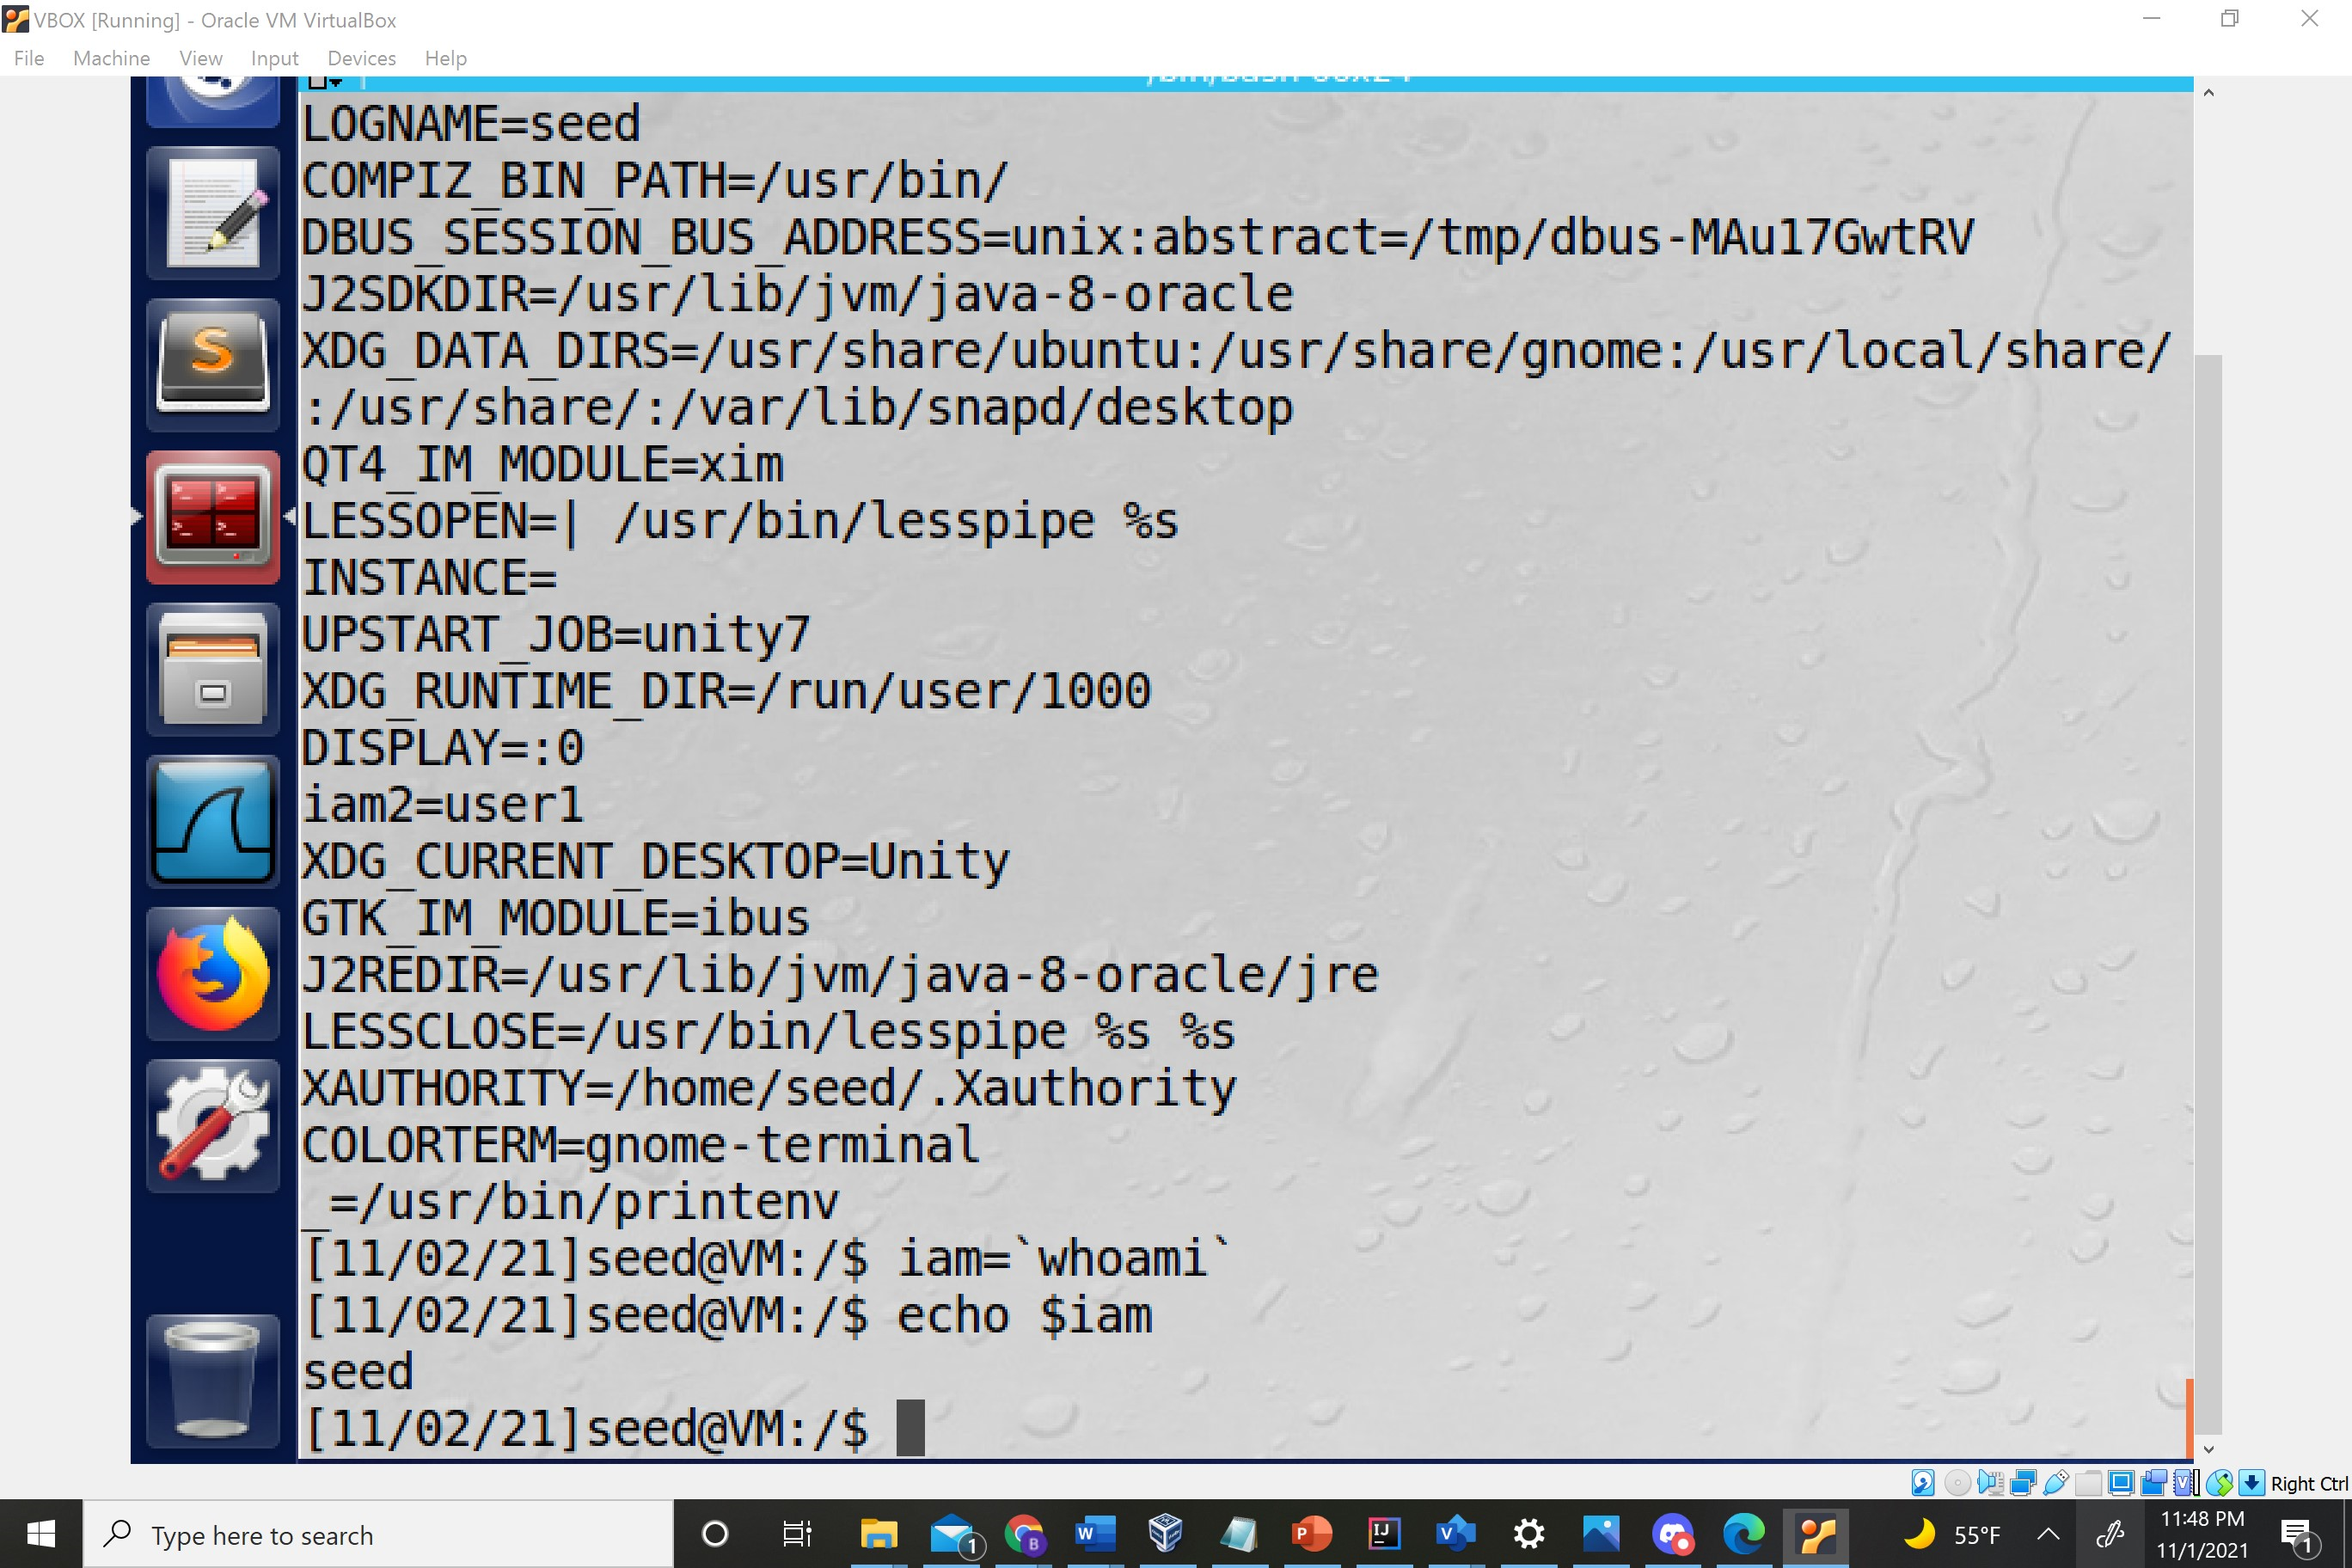

7. Change back to your home directory, if you are not in it. Use the set command to set up your working environment to prevent you from overwriting a file.

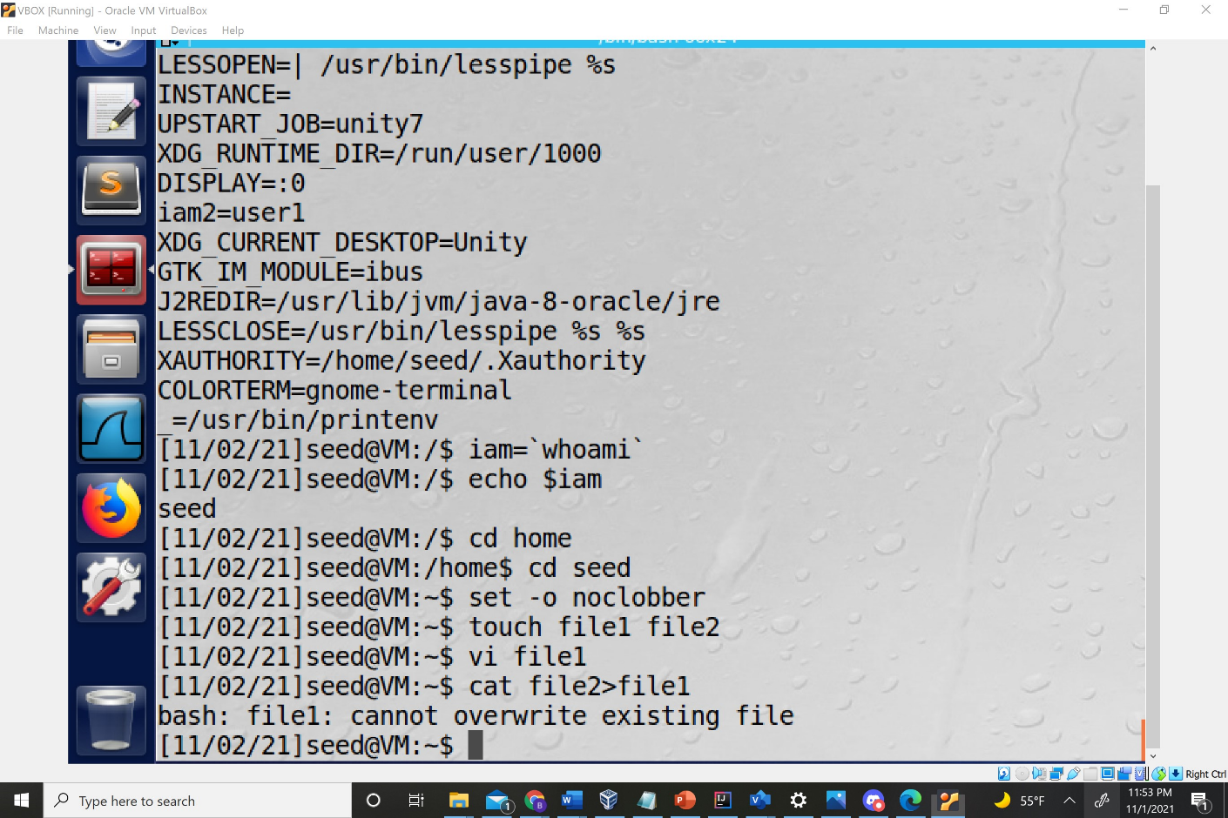

8. Create an alias called var that displays your environment variables

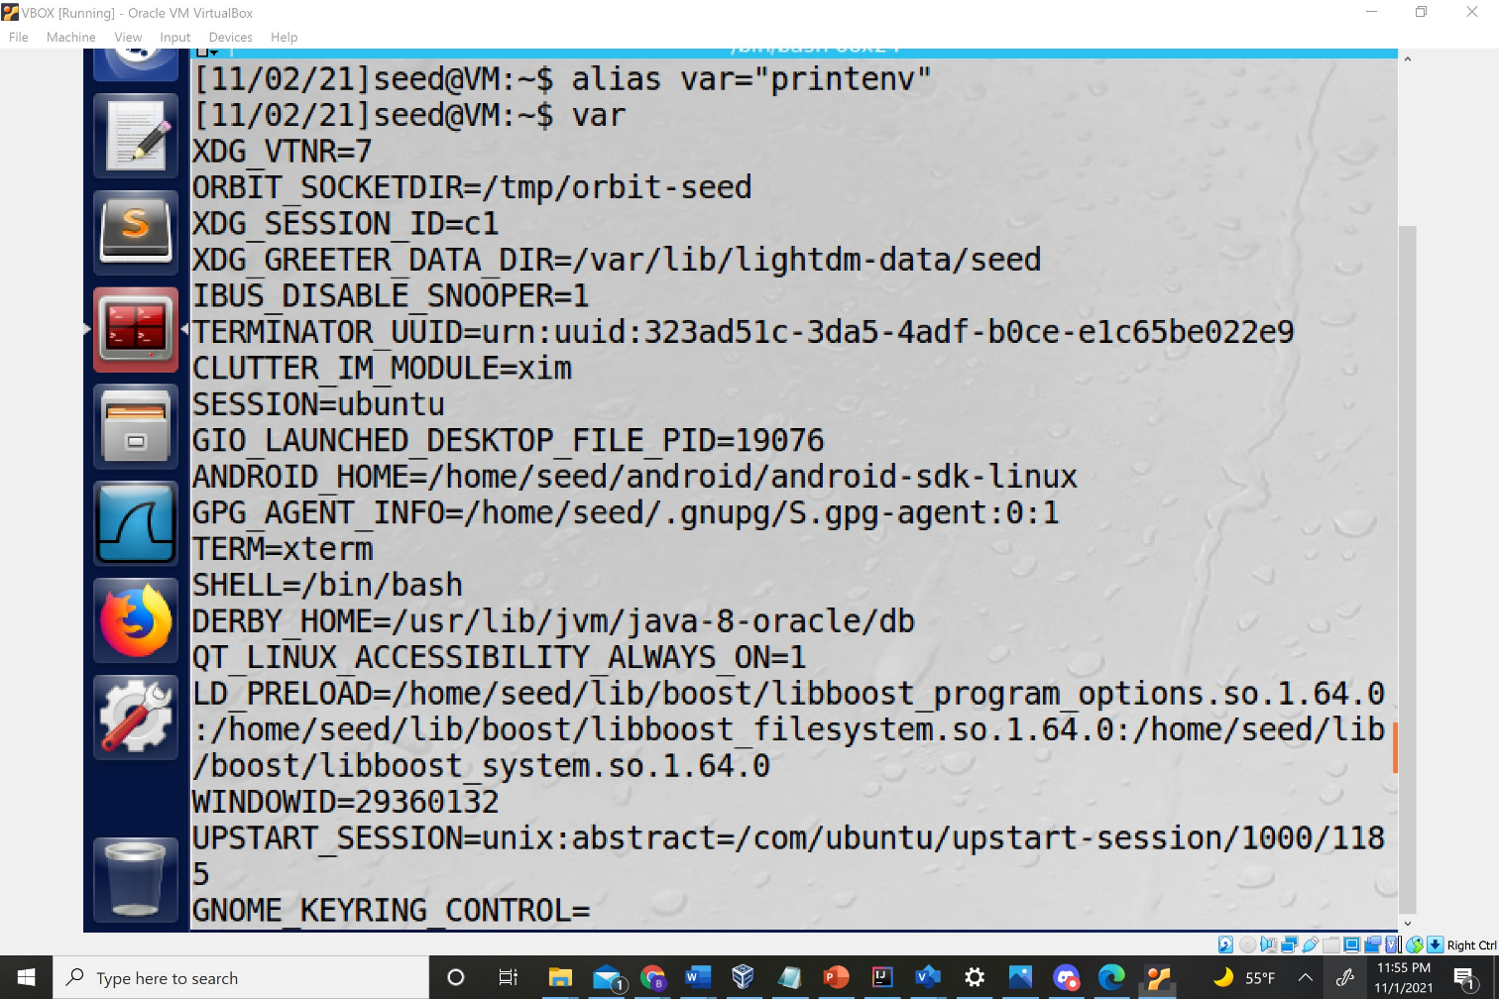

.9. At the command line, use a for loop that uses the variable sandwiches and then dis-plays a line at a time each of the following sandwiches: chicken, ham, hummus, tomato

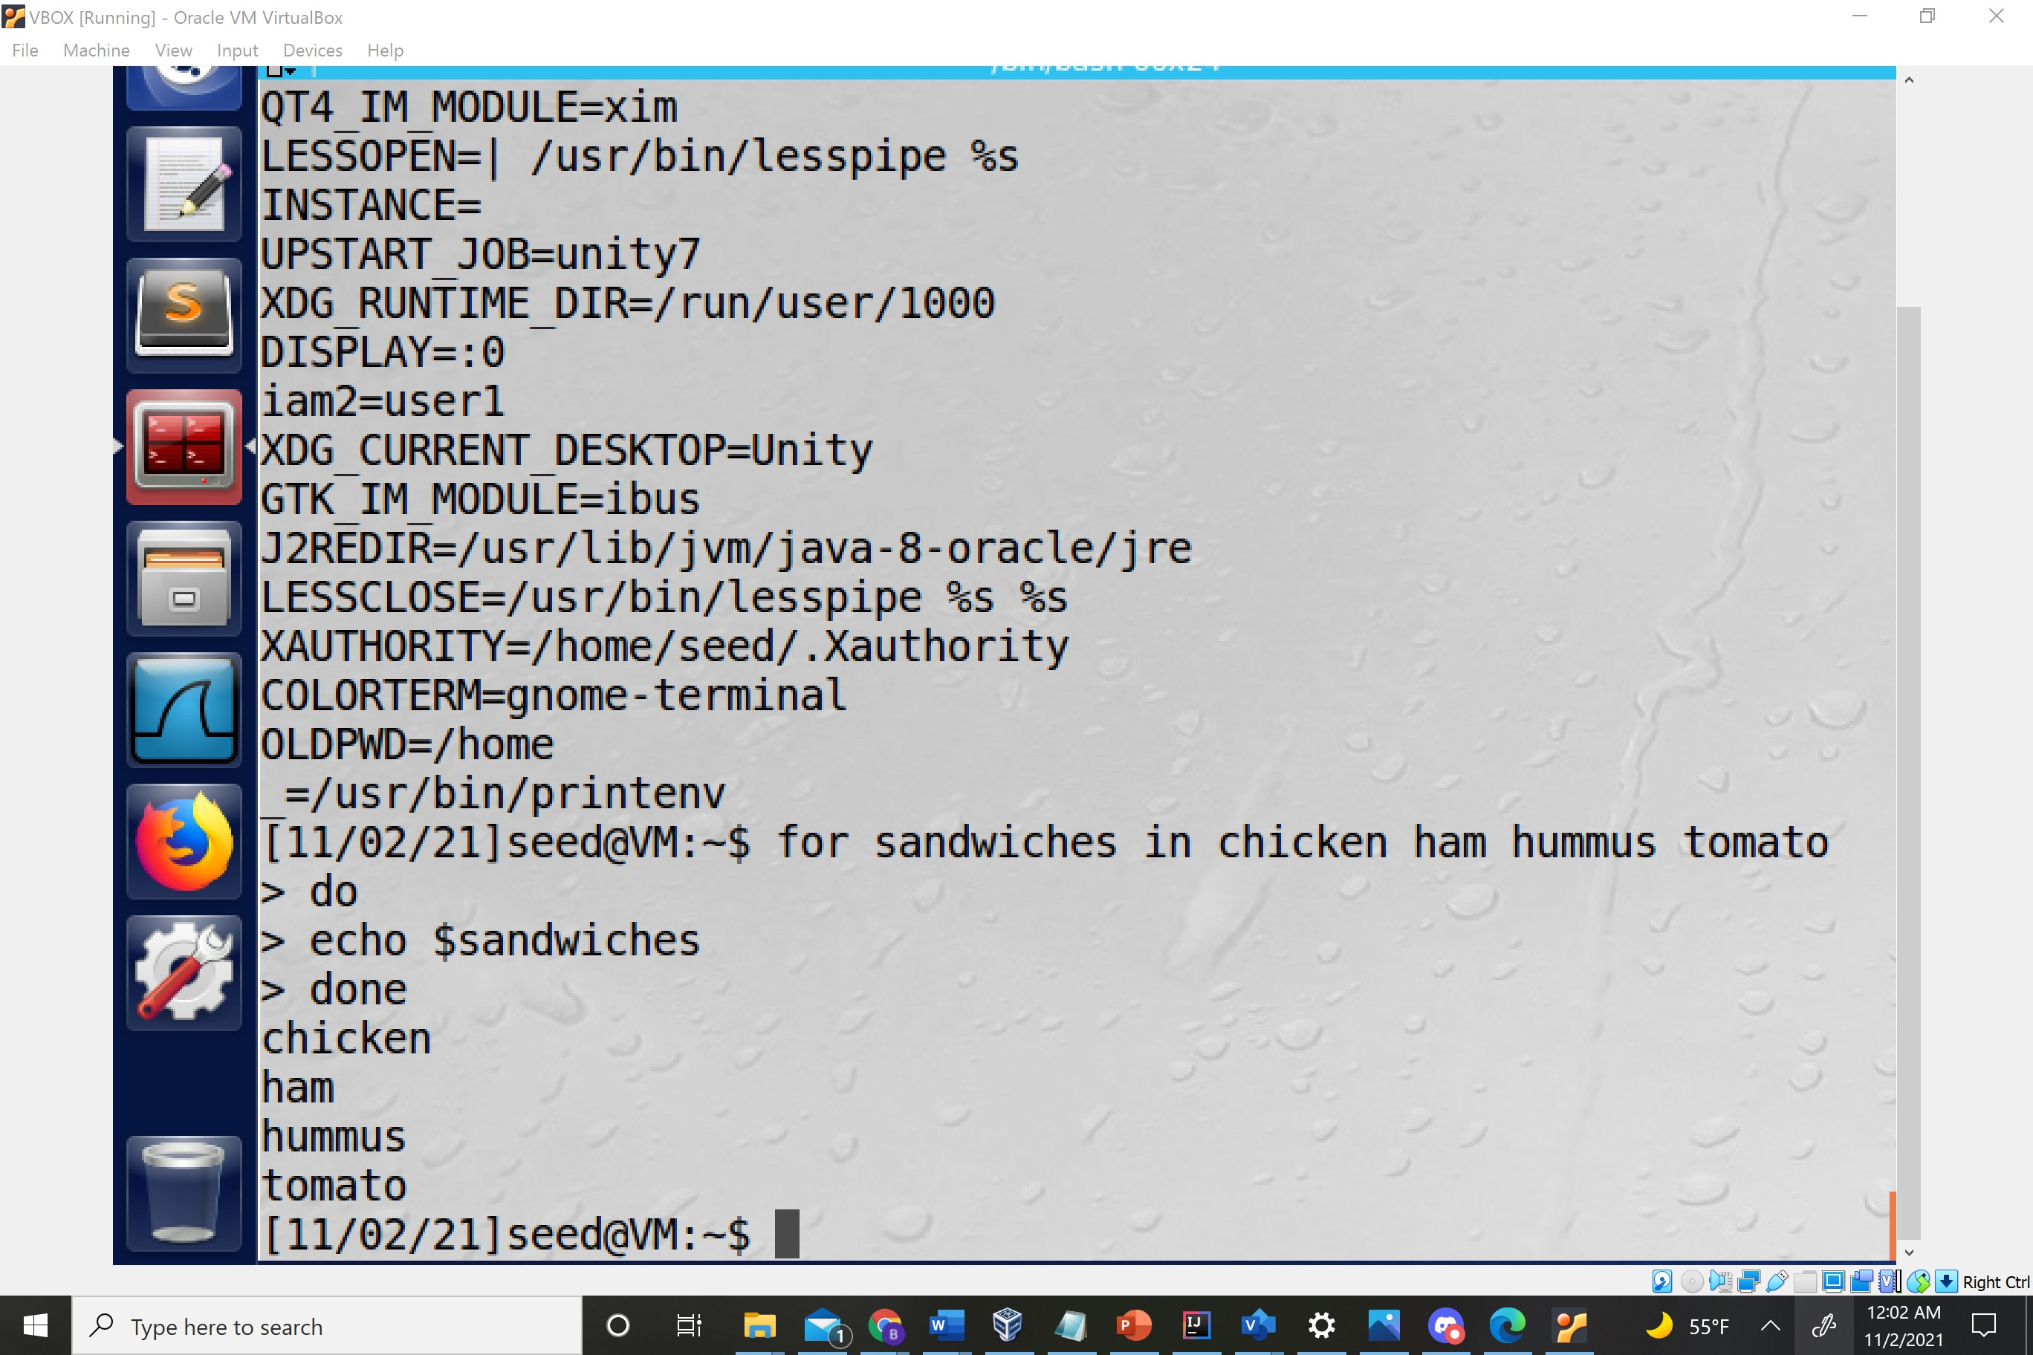

10. Create a script that uses case logic to have someone guess your favorite sandwich, such as tuna.

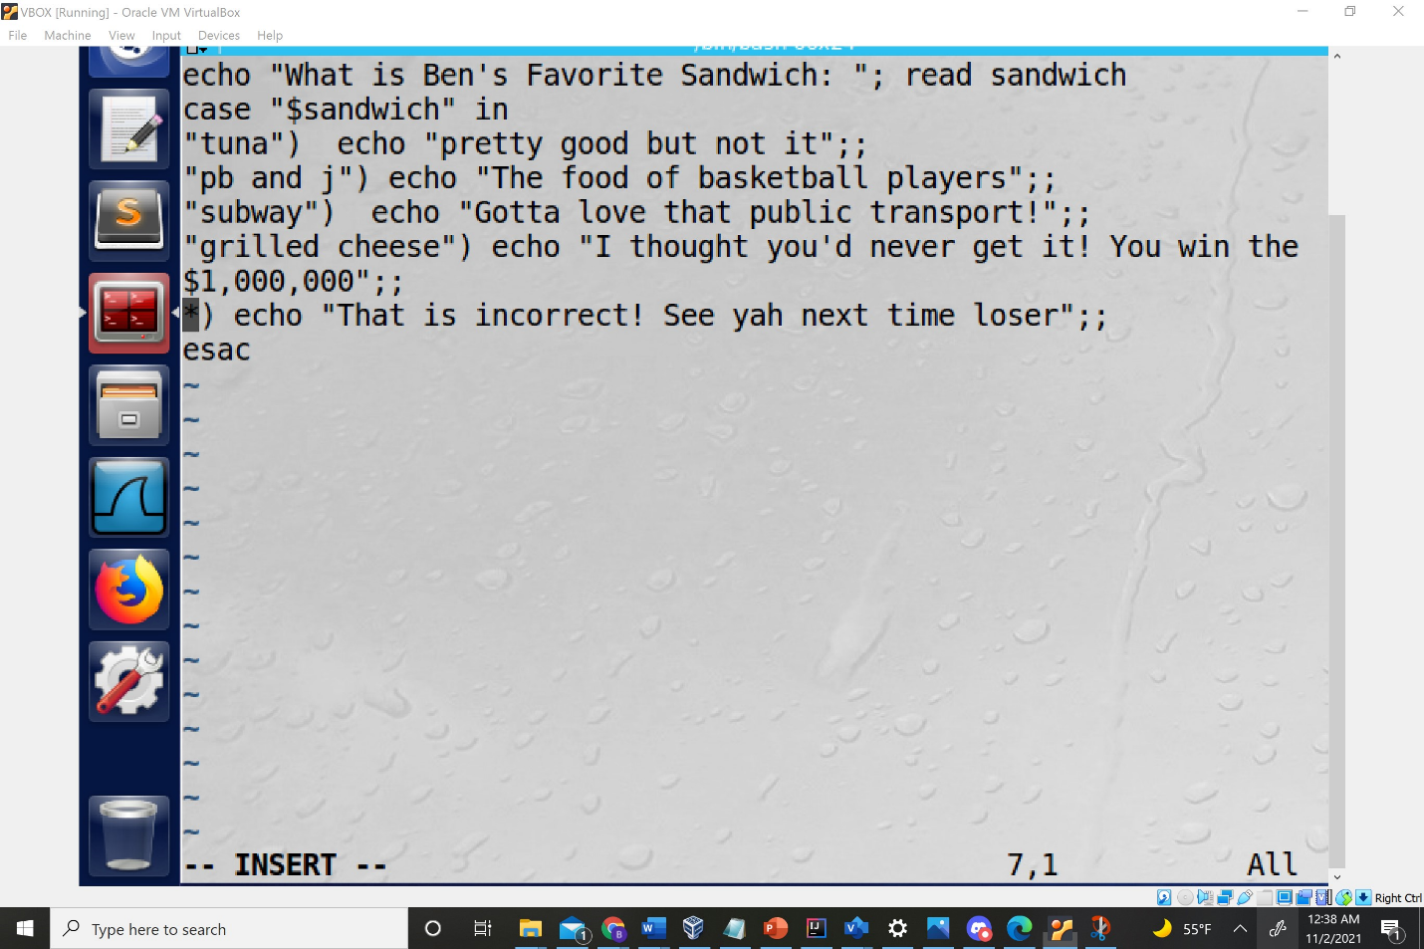

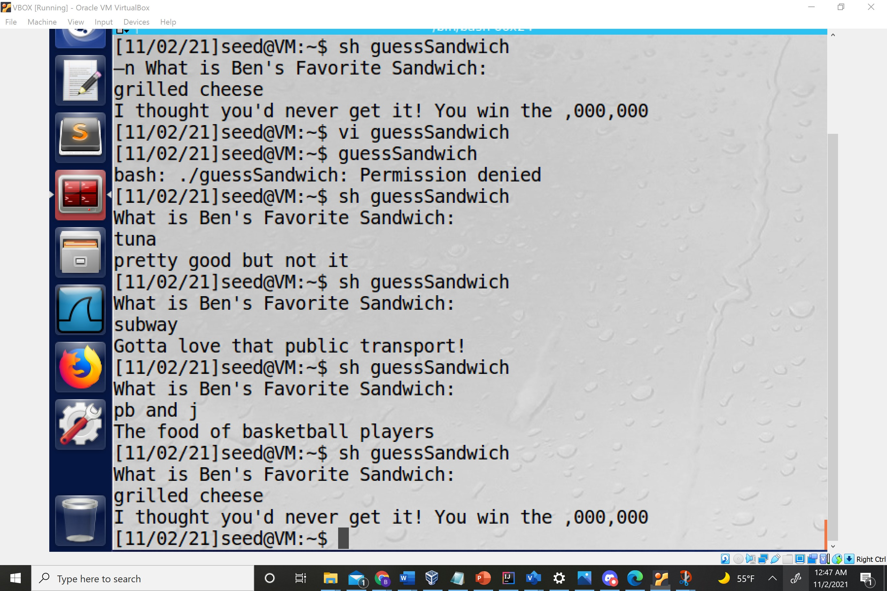

11. Display the contents of the .bashrc file. Next use the vi editor to edit that file and put in an alias so that every time you type list, you see a long file listing of a directory.

Used sudo vi to edit

Didn’t work initially but after I created a new instance of bash it worked.

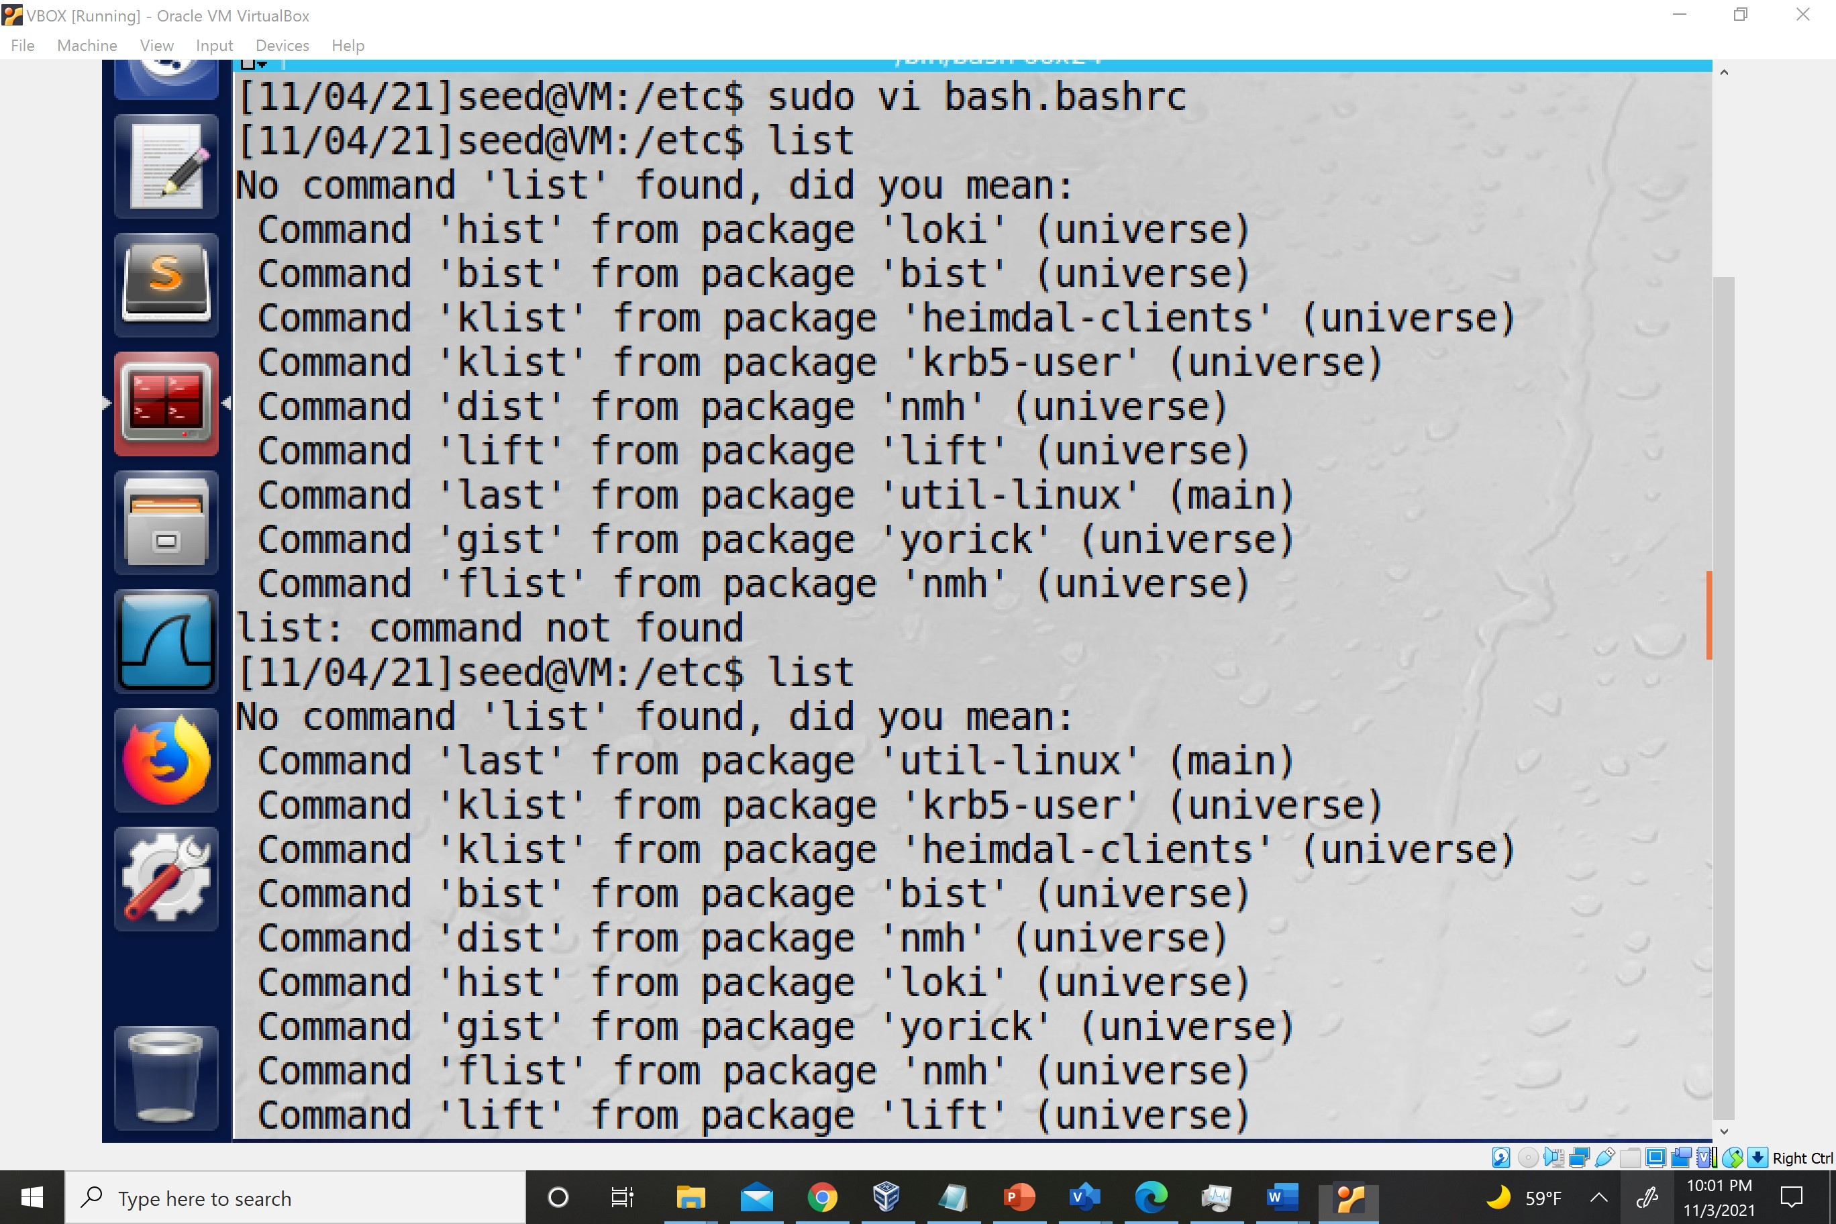

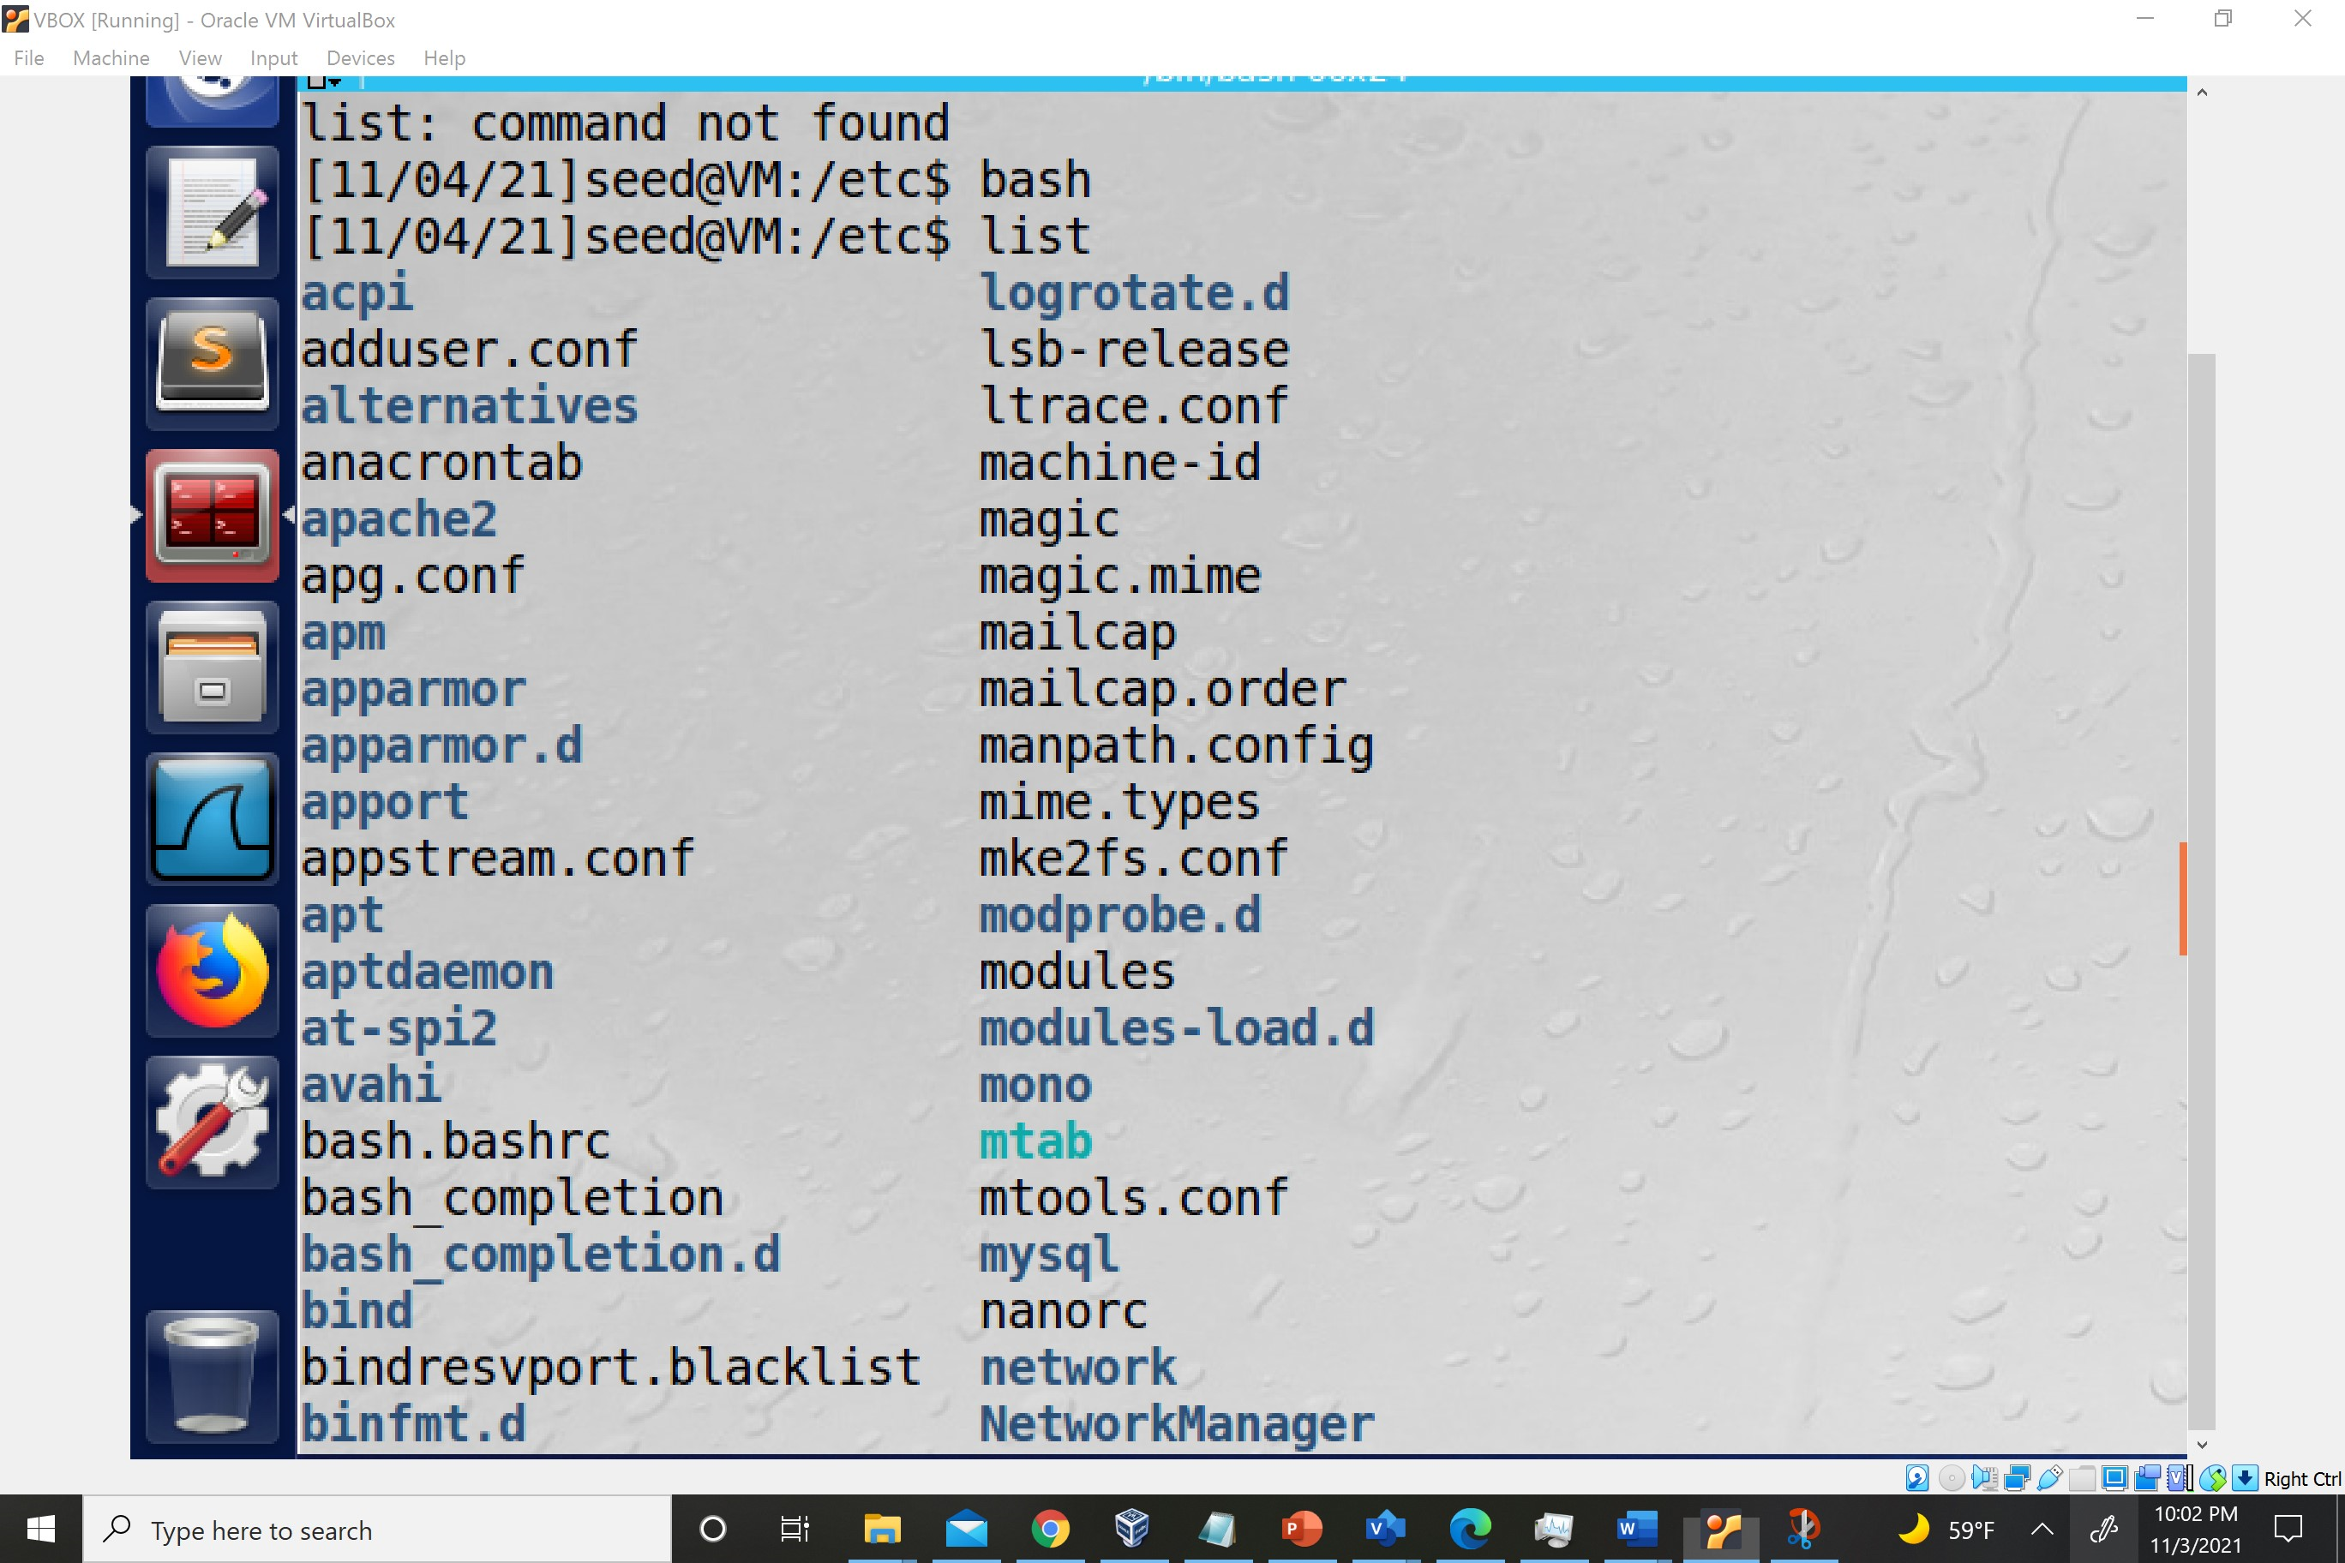

12. Use a command to simulate how you would troubleshoot a problem with the sand-wich script you created in Exercise 10.

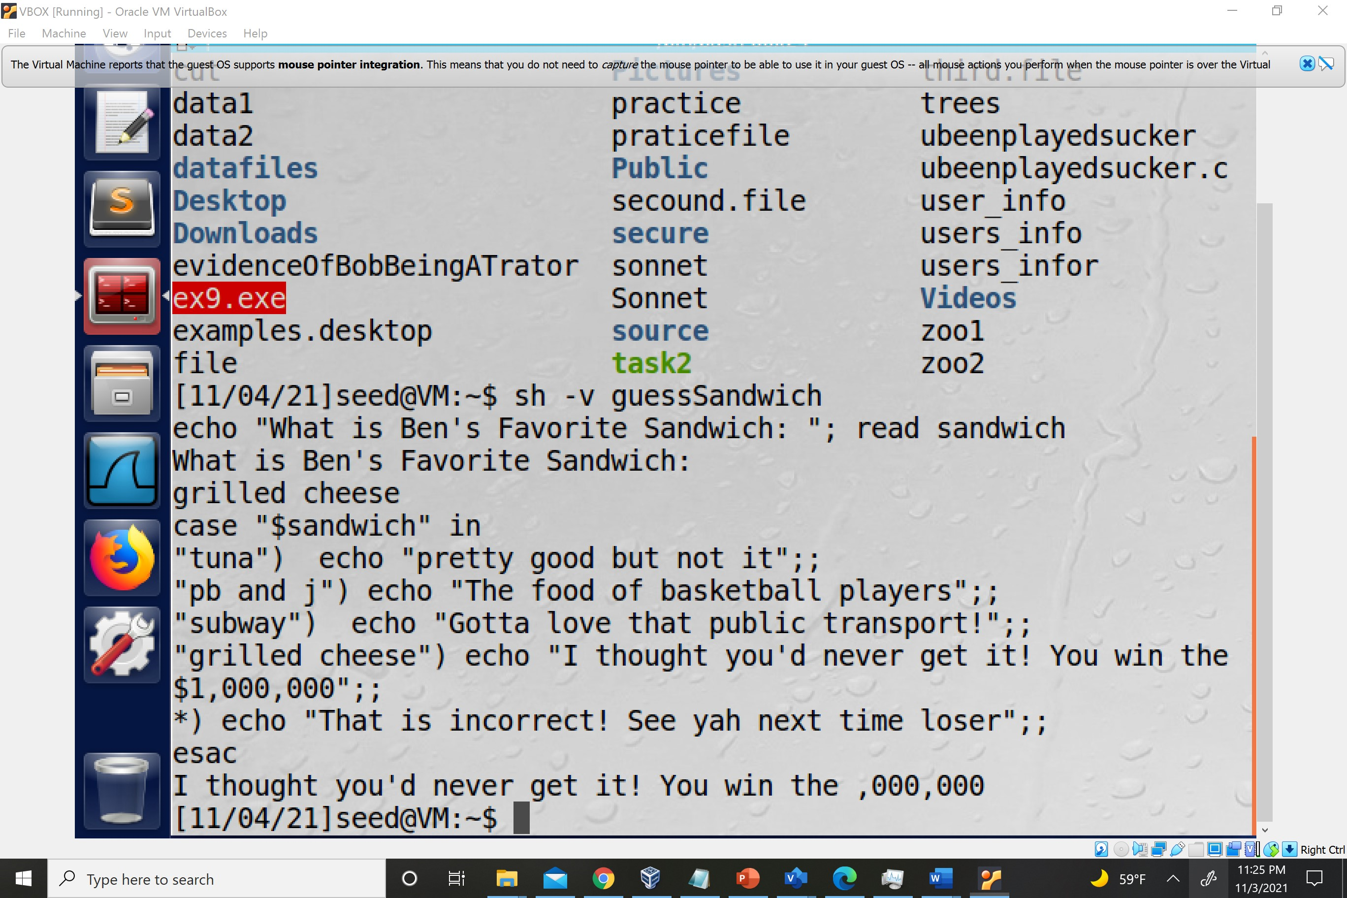

13. What is wrong with the following lines of code? While [ "$value" = "100" ; doEcho "That’s a large number." Read valuefi

14. Use theletcommand to store the value 1024 in the variableram. Display the con-tents ofram.

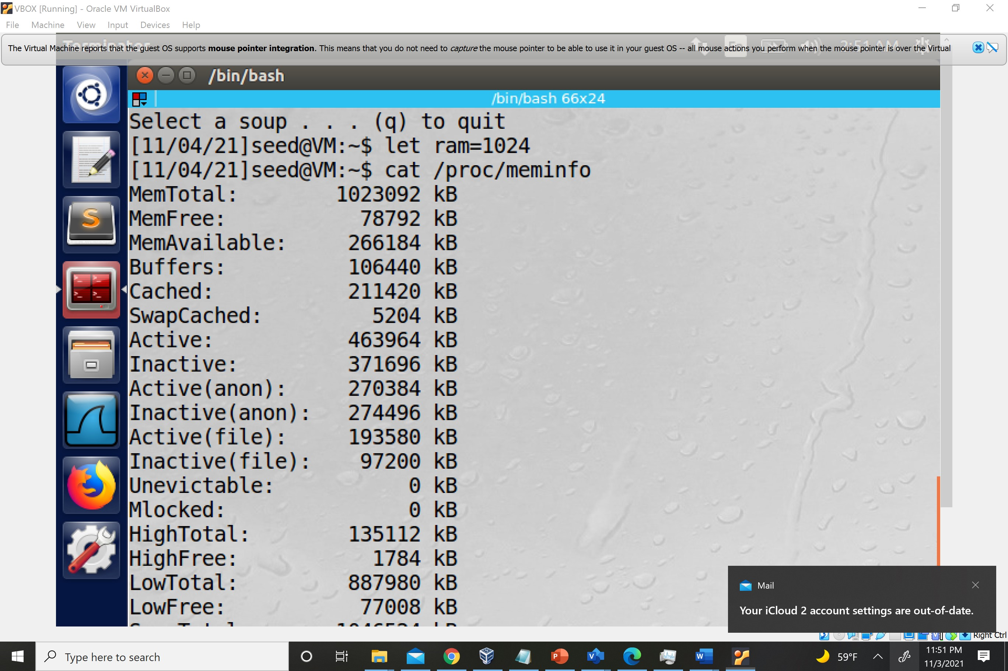

15. Temporarily change your home directory environment variable to/homeand thenuse one command to go to your home directory. Change the home directory envi-ronment variable back to your regular home directory and switch to it.

16. Use thetputcommand to clear the screen and then to place the cursor in row 7,column 22.

Result of tput clear; tput cup 7 22;

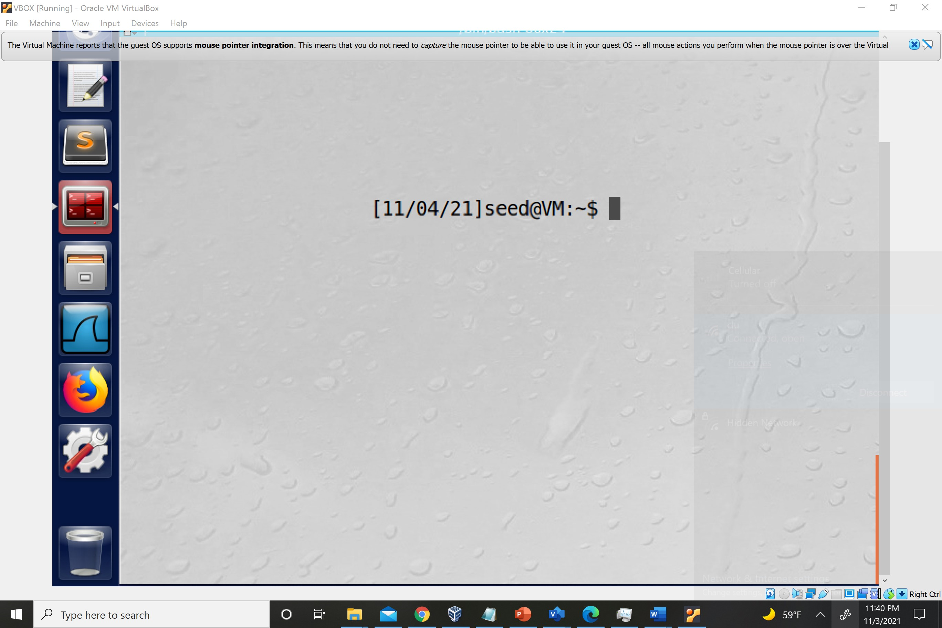

17. Write a script that creates the following menu:Soup Menu==========(t)omato(b)ean(s)quashSelect a soup . . . (q) to quit

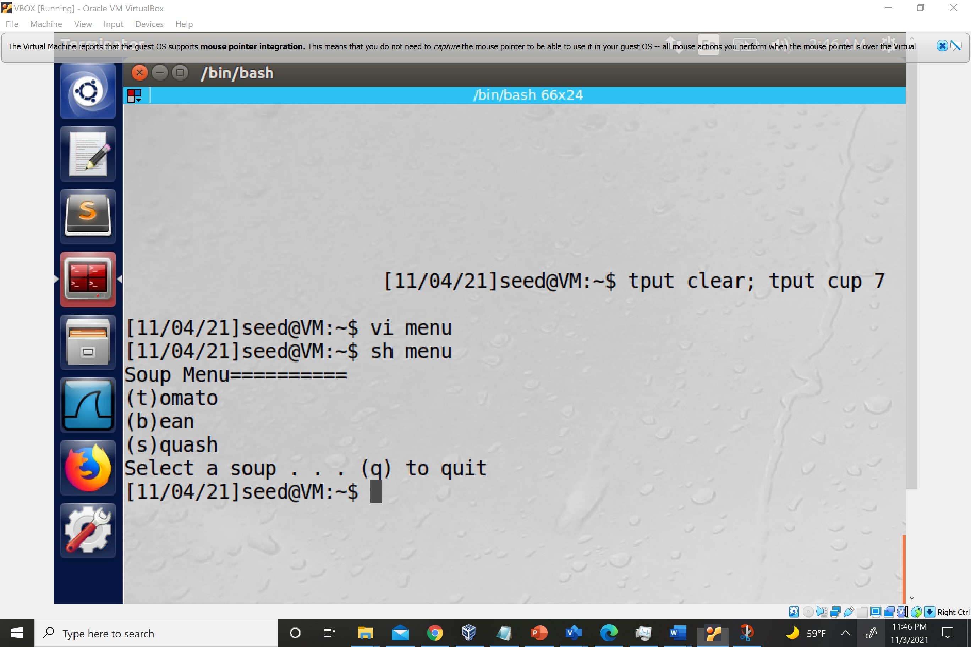

18. List all of the signal numbers and designations for thetrapcommand. What is thedesignation for signal 31?

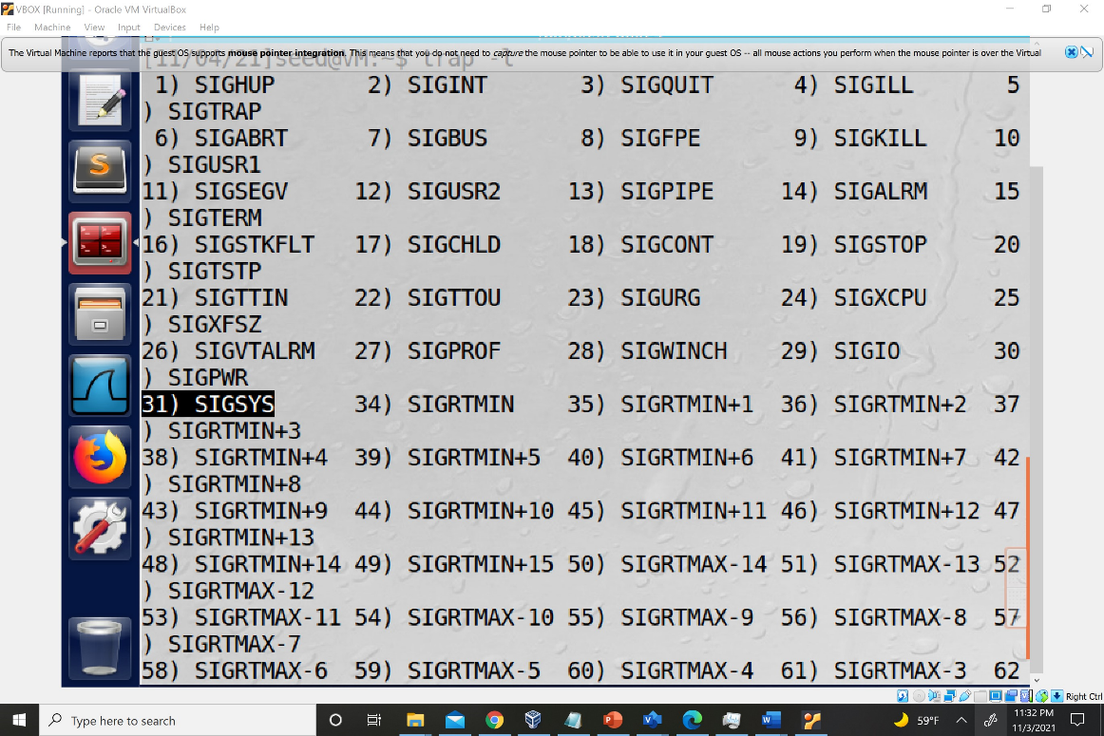

19. Modify your script from Exercise 17 so that there is a beep or bell sound when themenu is ready to take the user’s input.(Hint: review themandocumentation for theechocommand.)

20. Is there a command that you can use to prevent shell variables from being assignednew values? If so, what is it?"